

SIMATS ENGINEERING

Saveetha Institute of Medical and Technical Sciences
Chennai- 602105

Student Name:CH.Sai Reshma Reg. No.:192424098
Course Code:DSA0216 Slot: B
Course Name: Computer Vision with Open CV for Modern AI
Course Faculty: Dr. Senthilvadivu S & Dr. T. Kumaragurubaran
Project Title: Vision Based Sign Language Recognisation Using Cnn

Module Photographs: (3 photographs –Module Photo, Individual student contribution module work in the project and presentation image)
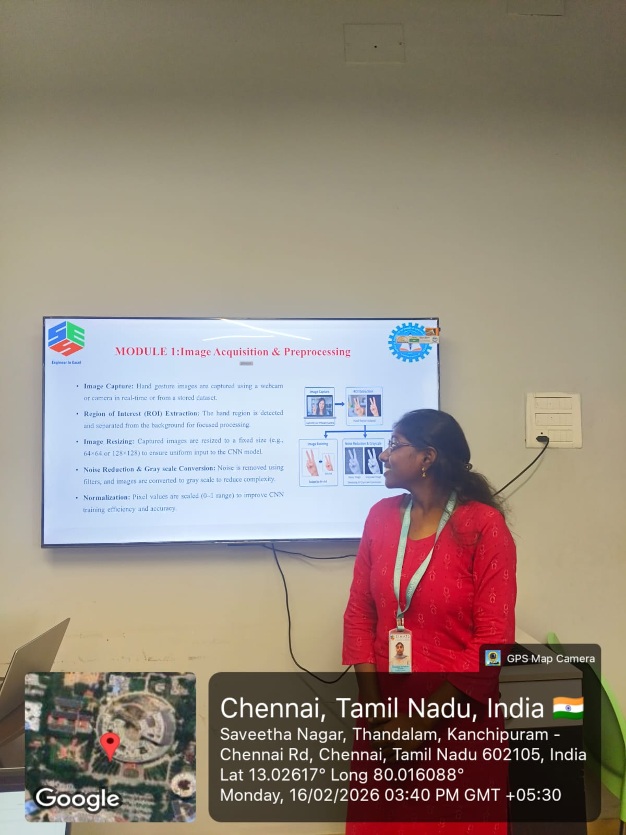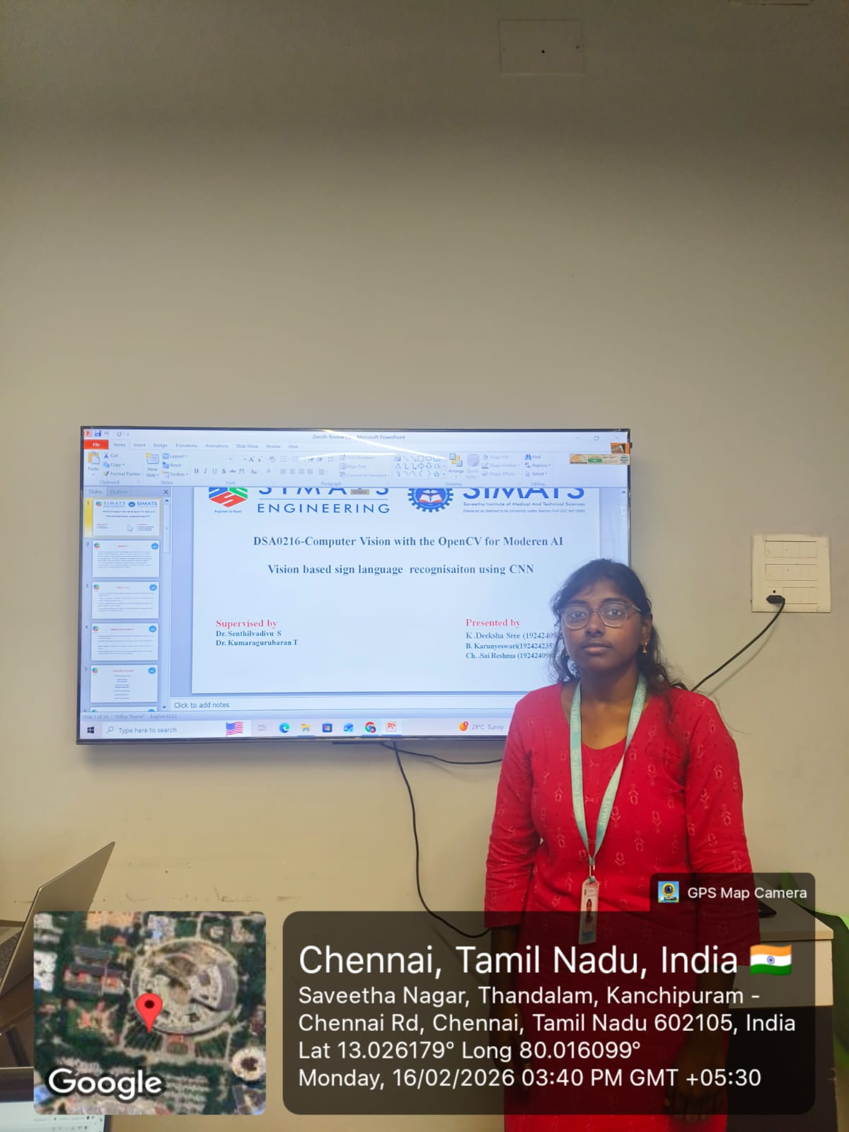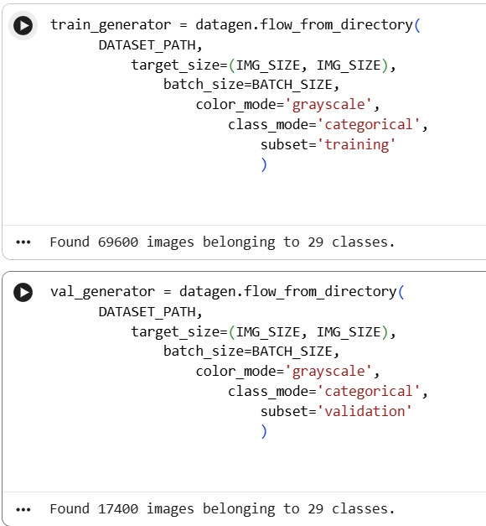

Project Description: (here you write what you did in this project (contribution) including Model Description
The Vision Based Sign Language Recognition Using CNN system is designed to automatically detect and recognize hand gestures representing sign language using a camera. The system helps bridge the communication gap between hearing-impaired individuals and others by converting sign gestures into readable text. It ensures accurate gesture detection and improves communication efficiency using deep learning techniques.
The Image Acquisition & Preprocessing module handles the capturing and preparation of gesture images before they are given to the CNN model. This module captures images or video frames using a webcam or camera and extracts the hand region from the background. It converts images into a suitable format such as grayscale or resized images to match the model’s input size.
The preprocessing step also includes noise removal, normalization, background subtraction, and contour detection to enhance the hand gesture features. These steps improve image quality and reduce unwanted variations caused by lighting conditions or background disturbances.
Overall, this module plays a crucial role in improving the accuracy of the CNN model by providing clean, standardized, and high-quality input data. It ensures that the system performs efficiently and recognizes sign language gestures reliably in real-time applications.

Student Signature Guide Signature

